- Our sentiment data, developed with Penta, suggests that UK private sector wage growth slowed sharply in March and early-April. If official data mirrors our sentiment indicator, it should keep the Monetary Policy Committee on track to cut interest rates in the summer.
- Our nowcast also shows that labour demand continued to slow gently in the first months of 2024. In contrast to the significant volatility in recent Labour Force Survey data, our sentiment indicator points to a steady loosening in labour market conditions, more in keeping with the picture from recent data on job vacancies.
- Sentiment around talent and HR has dropped sharply in recent weeks, suggesting firms are finding it easier to recruit. Other labour demand scores are at, or below, historical averages. Sentiment around remuneration has also fallen, suggesting looser labour market conditions are mitigating the boost to pay growth from the large increase in the National Living Wage in April.
Coming on the back of stronger-than-expected US inflation data, financial markets reacted hawkishly to a modest upside surprise for UK pay growth in February. Headline (three-month average of the annual rate) private sector regular pay growth – the Bank of England's favoured measure – only fell to 6% in February from 6.1% in January. This means there's a good chance that pay growth will overshoot the BoE's Q1 forecast of 5.7%, thus reducing the chances that the Monetary Policy Committee concludes that the risks from persistent inflationary pressures have receded enough to begin cutting interest rates.
But our proprietary high-frequency sentiment dataset, developed in collaboration with Penta, suggests that the picture has started to change. Our latest update is based on data for March and the first half of April. The sentiment data-based pay nowcast shows an abrupt slowdown in recent weeks (Chart 1). What's more, this slowdown came after a run of stronger data around the turn of the year.
Chart 1: Our nowcast data suggests pay growth has slowed abruptly in recent weeks
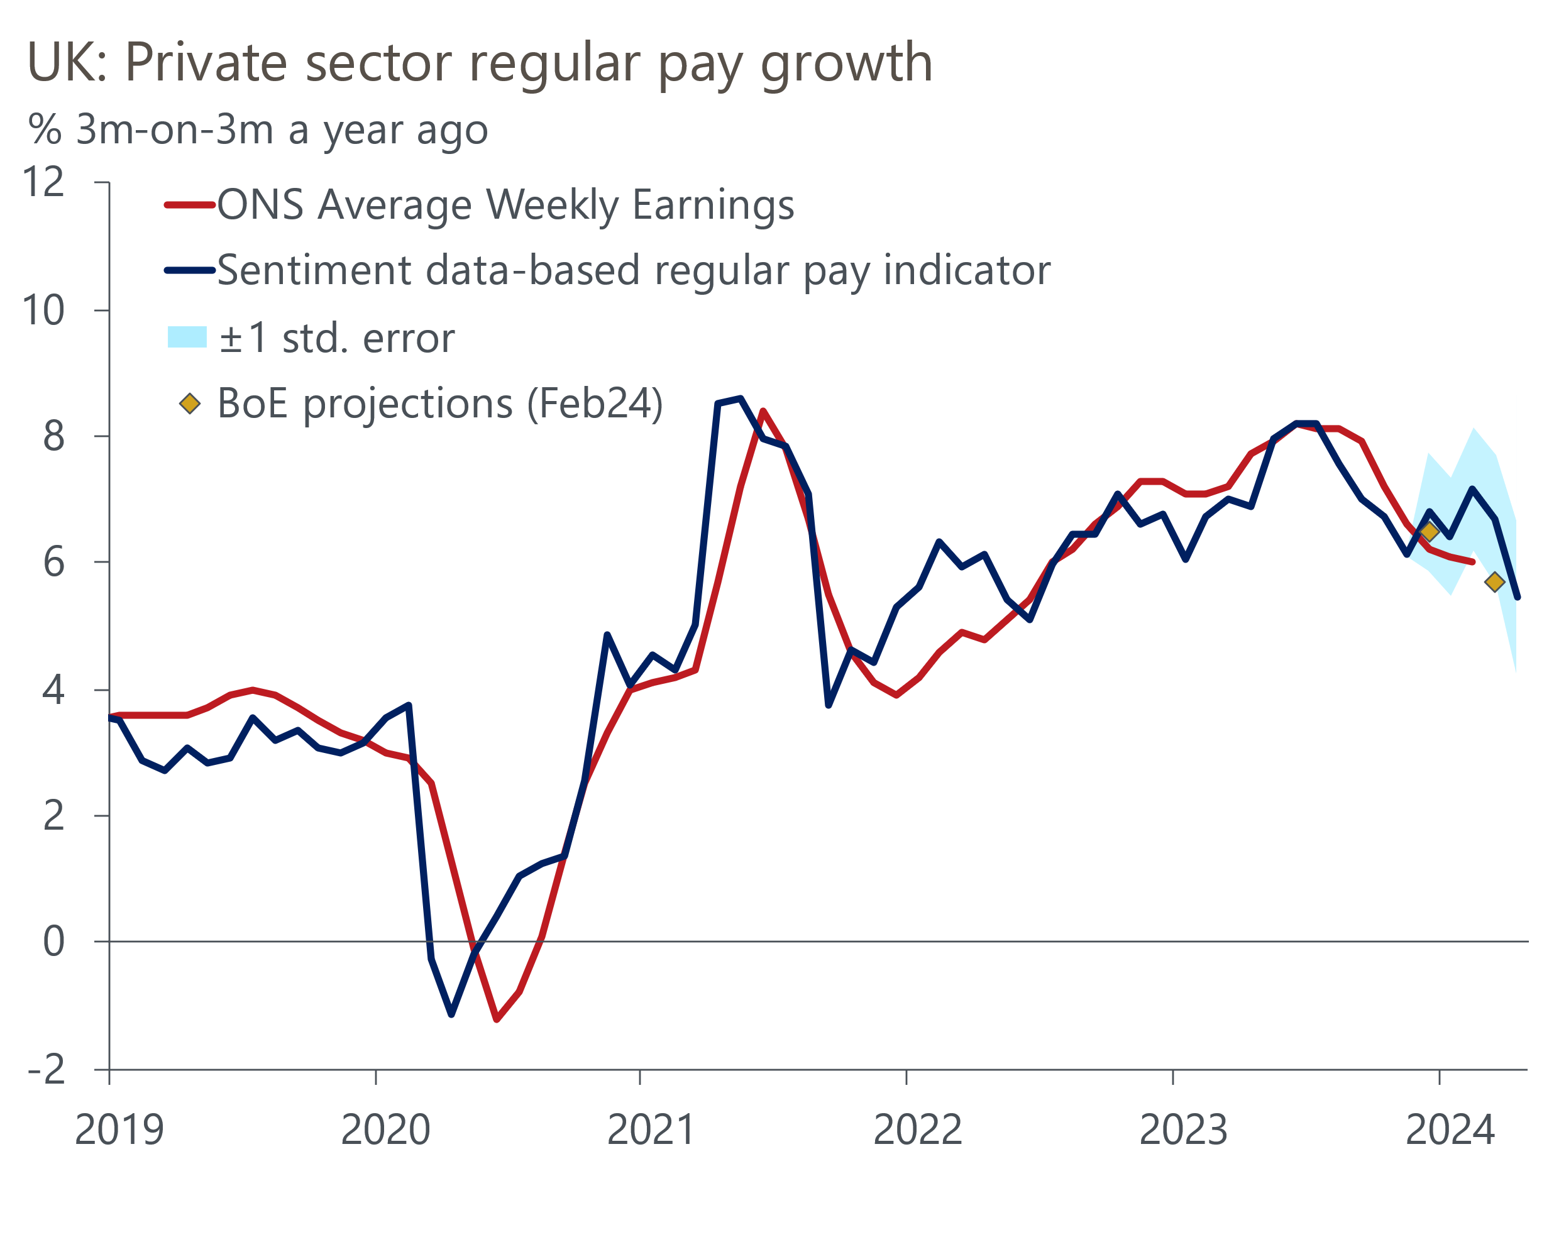
Sources: Oxford Economics, Penta, Haver Analytics

One complication is that our modelling approach may not fully capture the impact of idiosyncratic events such as April's near-10% increase in the National Living Wage. An S&P Global survey in that month reported a marked impact on firms' costs, particularly in the services sector. But the scale of the slowdown indicated by our sentiment indicator suggests that the ONS measure of pay growth could continue to cool, despite the rise in the NLW. What's more, the NLW increase was announced in November 2023, so some of the impact is likely to be spread over the course of several months. It may even have been a factor behind the strength in March.

Employment growth continues to steadily cool
Our employment nowcast shows a continuation of the slowdown in labour demand flagged by previous updates, with headcount now broadly flat on a year-on-year basis (Chart 2). This is a much less abrupt slowdown than that flagged in the latest Labour Force Survey data. But the ONS is still to resolve the bulk of its sampling problems and recommends caution in interpreting the LFS data.
Chart 2: Employment growth continues to gradually cool
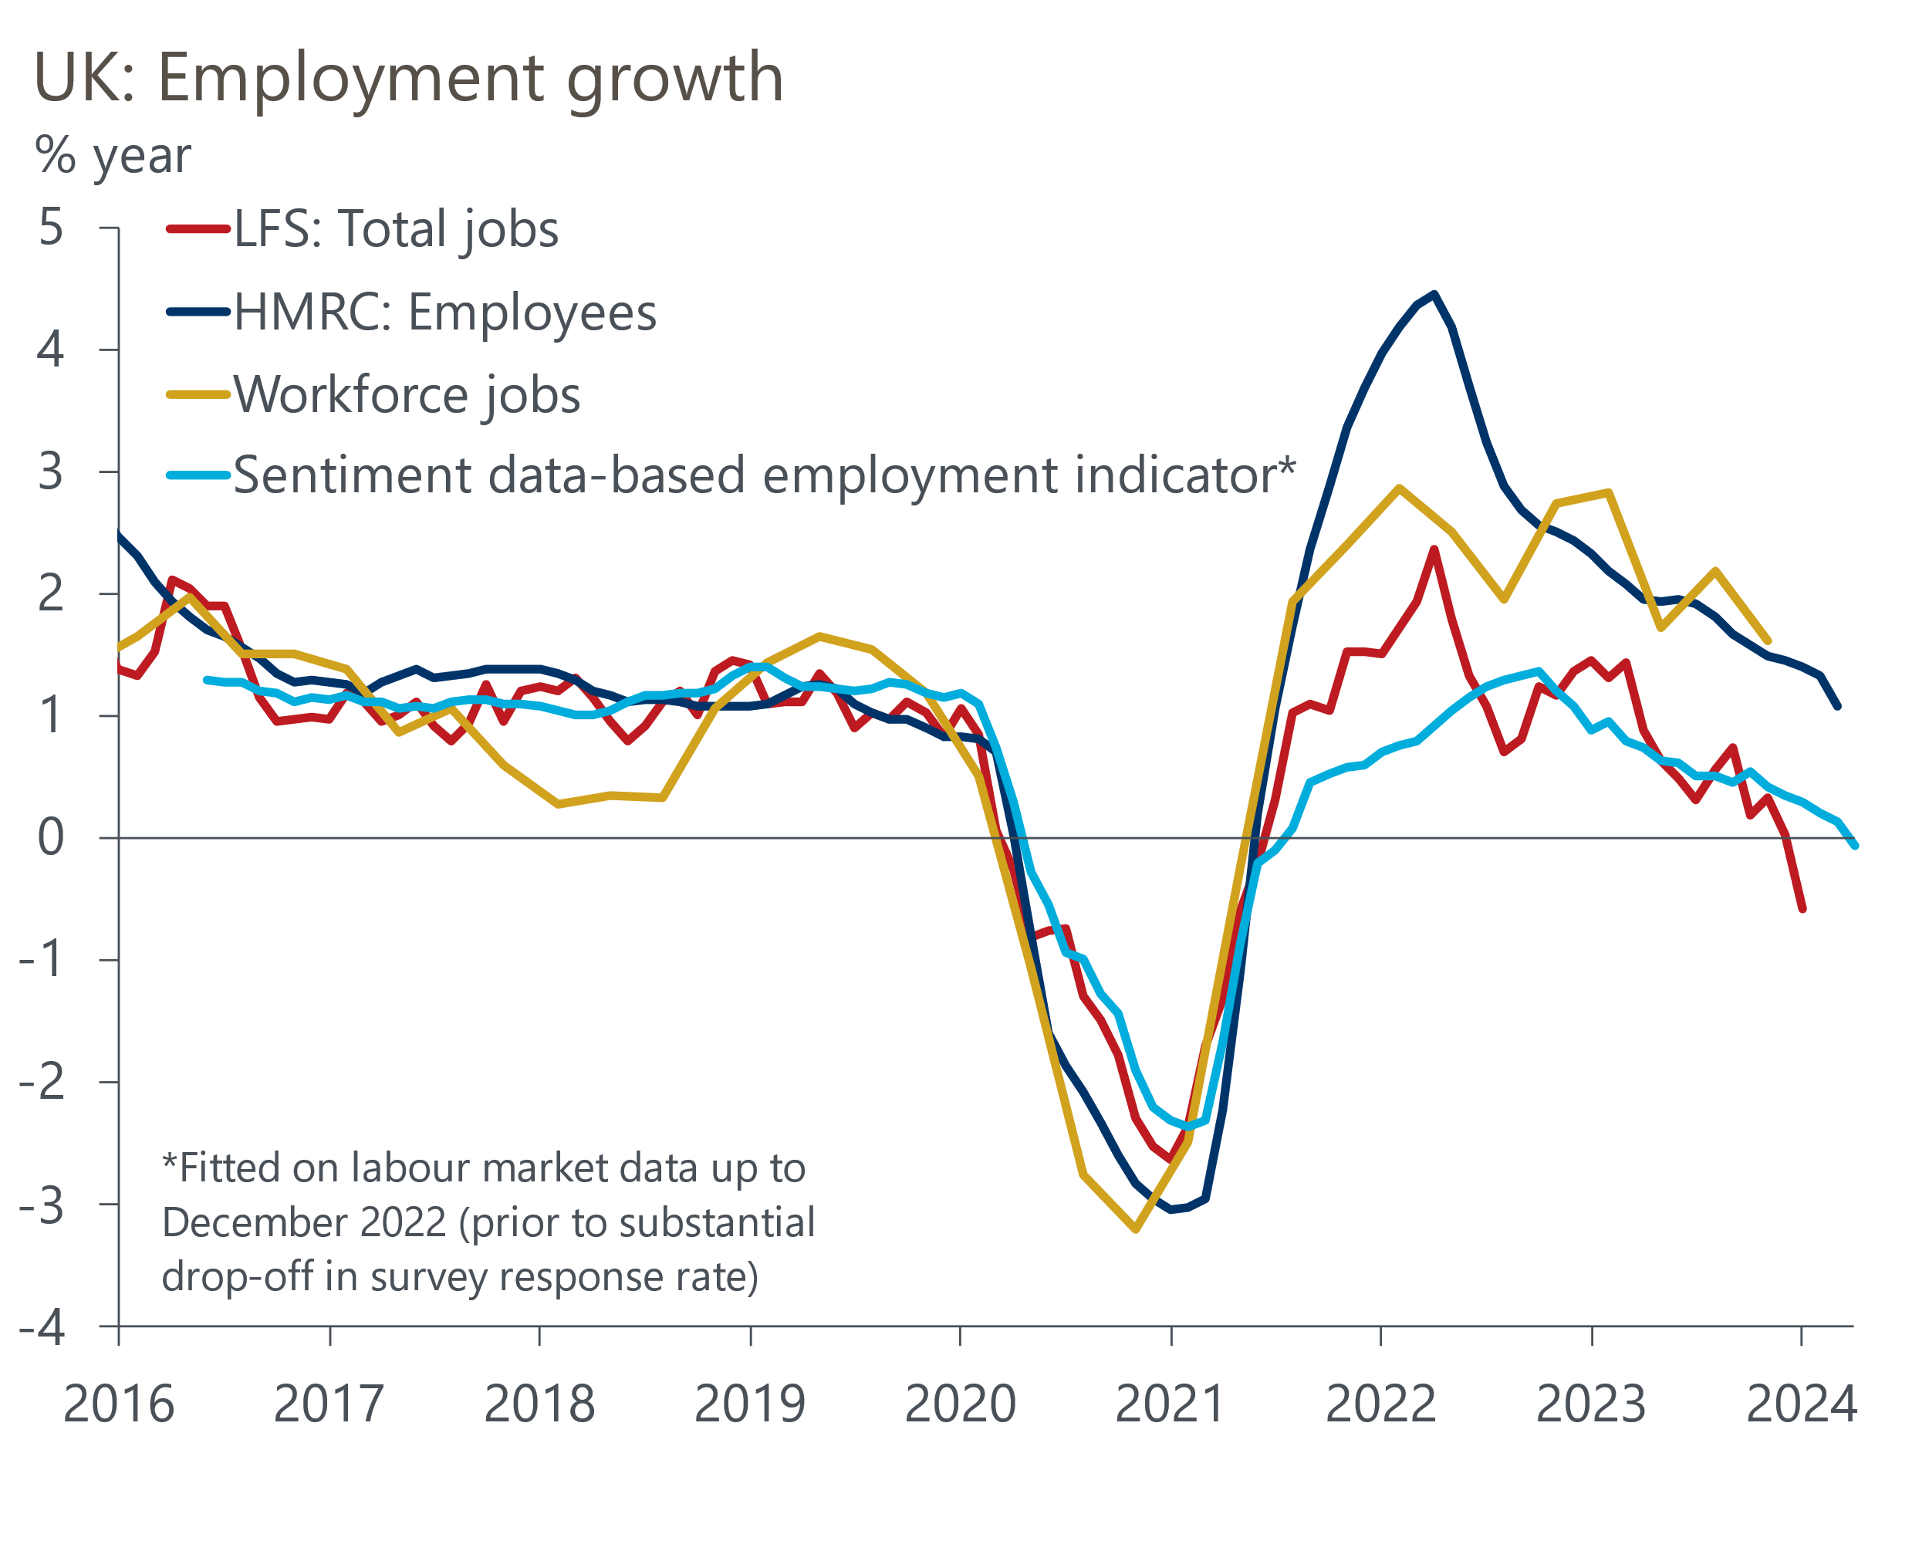
Sources: Oxford Economics, Penta, Haver Analytics
Other series have also been more consistent with the picture painted by our sentiment data. Annual growth in HMRC's count of payrolled employees has a similar shape to our nowcast series over the past year, and though its growth rate has been higher, initial HMRC estimates tend to be revised down. The ONS's vacancies series also continues to drop slowly, not precipitously, and remains well above pre-pandemic levels.
So we think the latest LFS outturn will prove to be noise and that labour demand is gently cooling, not slumping. Given that activity has begun to recover at a decent pace in early-2024, we could be close to the trough in employment. Still, the turnaround probably won't come quickly enough to stop the year-on-year change in our sentiment data-based employment indicator briefly dipping into negative territory.

Detailed sentiment data is consistent with loosening labour market conditions
The strength of labour supply means that flat employment should be consistent with loosening labour market conditions. The individual sentiment series for labour market-related topics used in our nowcasting indicators back this narrative. The scores for jobs, recruitment, and expansion plans are all at or below their long-run averages (Chart 3). And though the score for Talent and HR is higher than historical norms, it has fallen sharply from its early-December peak. This suggests that firms are finding it much easier to recruit than before.
Chart 3: Individual sentiment series are consistent with loosening labour market conditions
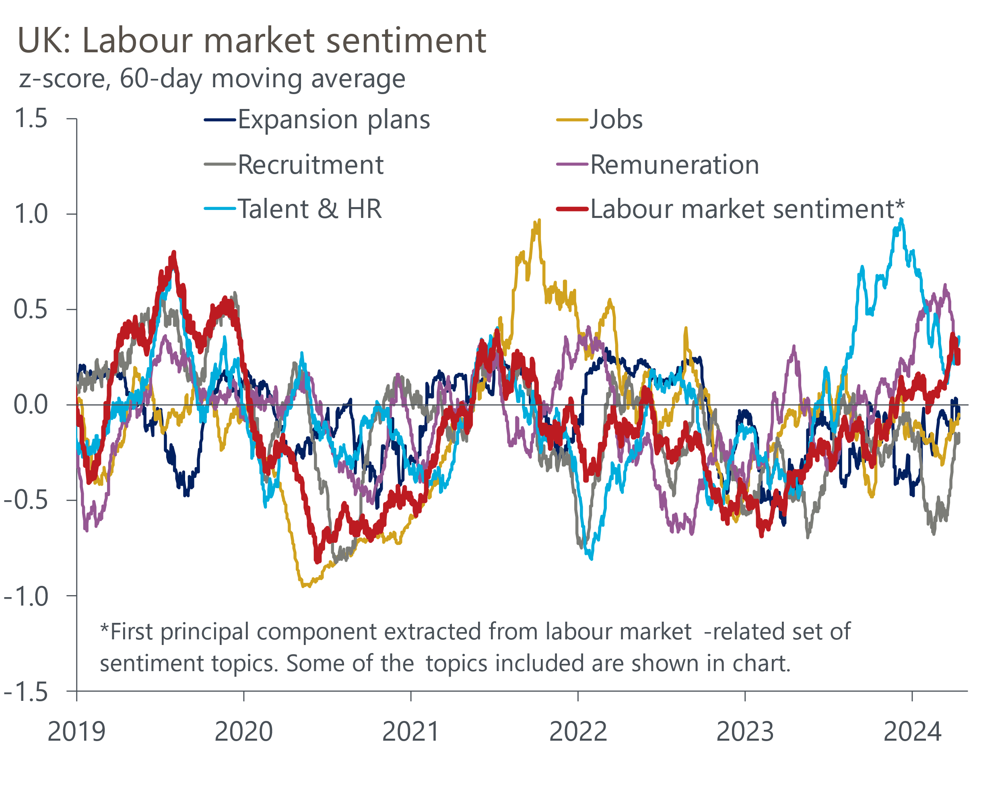
Sources: Oxford Economics, Penta

Nowcast data suggests summer rate cut remains on the table
After the recent labour market and inflation releases, financial market sentiment moved to the extent that a rate cut wasn't fully priced until the autumn. Subsequently, a relatively dovish speech by BoE Deputy Governor Dave Ramsden led markets to retrace their steps. At the time of writing, market pricing implies a first rate cut in August.
Our nowcast data is consistent with a summer cut. Indeed, if official measures of pay growth slow to a similar extent to our nowcast, which is close to the BoE's projection for Q2 from February's Monetary Policy Report, there's still a good chance that the first cut will come in June, in line with our current baseline. As we've previously argued, the April data for pay and inflation is likely to prove key. The pay data will show the impact of the NLW rise, while the inflation data will show the impact on core inflation of the annual increases for index-linked contracts and regulated prices.
Both releases will be available to the MPC at its June meeting. If the data confirms that pay growth and core inflation are on a downward trajectory and are progressing in line with the MPC's February forecasts, then we think that would be enough to convince a majority to switch to voting to cut. But the internal bloc appears to be less united than before – this week BoE Chief Economist Huw Pill said the monetary policy outlook "has not changed substantially" since his March speech, when he had argued that rate cuts were "some way off". So it's likely to be a close call and we wouldn't be surprised if some of the BoE insiders opt to err on the side of caution, making us wait until August before there's a majority to cut.

